11-July-2013 – Initial writing – Steve Rance
Xynergi LCD and EVO TFT Controller Exchange
The original Controllers Cards for both the Xynergi/XCS and EVO TFT screens were based on a now obsolete controller card. The new controller is based on a MS460LC design.
Although the MS460LC is a drop in replacement two connectors have changed their orientation and need to be flipped 180 degrees.
The photo below shows the original part.
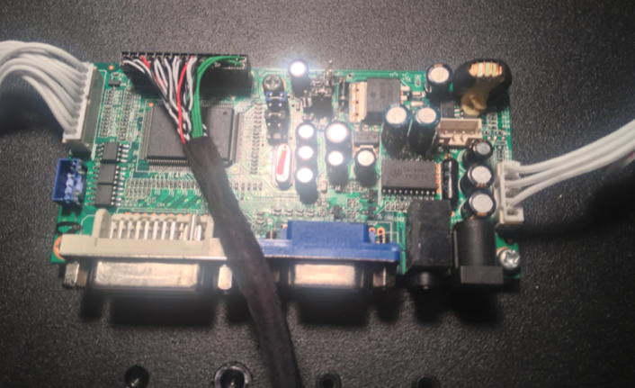
Notice the far left connector (gray ribbon cable) and the multi-way connector with the green wires.

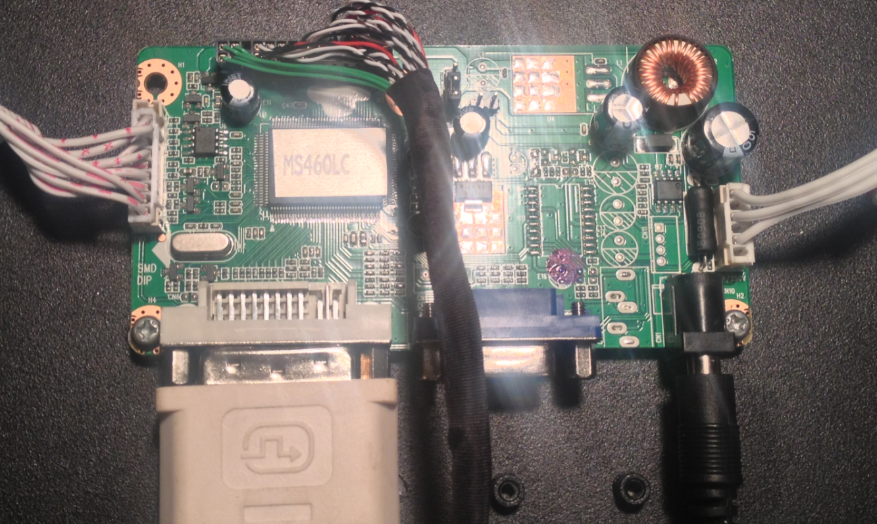
The photo above shows the new replacement part (the MS460LC)
- The gray ribbon cable on the far left has been rotated 180 degrees and because of the extra set of pins is biased towards the DVI connector.
- The cable loom with the green wire harness has been rotated 180 degrees.
- The Invertor feeder cable on the right remains the same.
PLEASE NOTE THAT ALTHOUGH THE BOARD IS THE SAME, THE XYNERGI/XCS BOARD CANNOT BE INTERCHANGED WITH THE EVO TFT SCREEN. THEY ARE PROGRAMMED DIFFERENTLY FOR THE TWO TYPES OF LCD SCREENS USED.
Replacement boards can be ordered from Benson@lcdparts.net asking for a …
MS460LC programmed for a Sharp LQ150X1LGN2A (Xynergi/XCS Panel)
or
MS460LC programmed for the M200O01 Panel (EVO TVT Screen)

